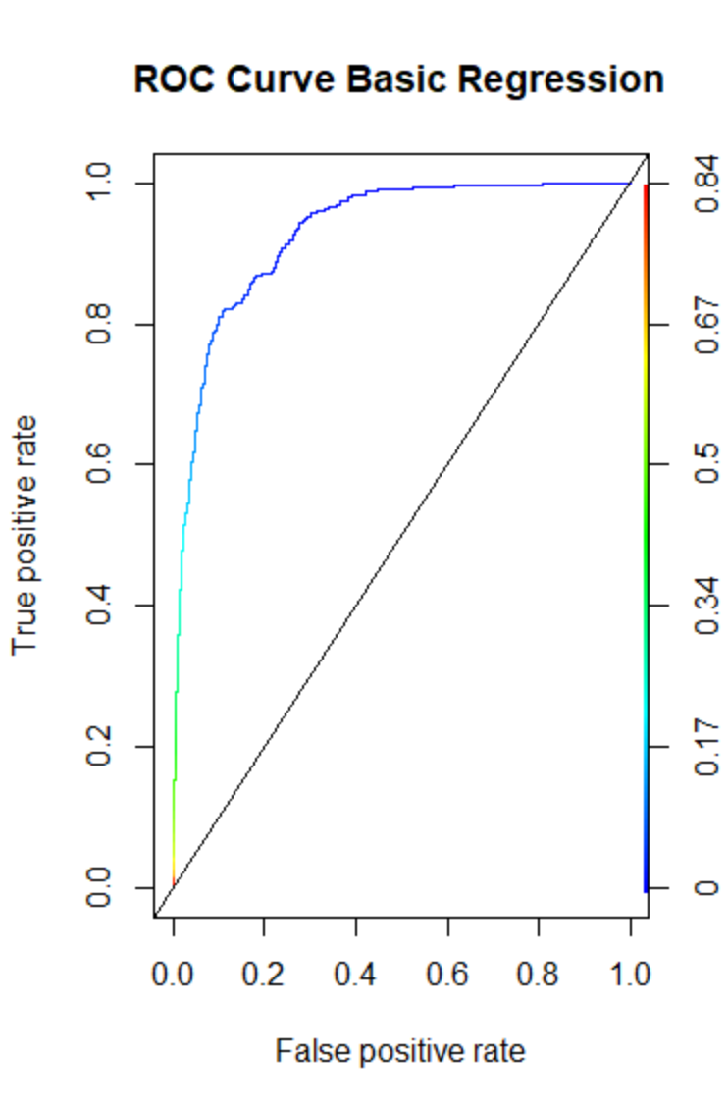

Basic Regression

|  |  |
| --- | --- |
| Accuracy | 0.9611691 |
| truePos | 0.1891892 |
|  |  |
|  |  |
|  |  |
|  |  |
|  |  |
|  |  |

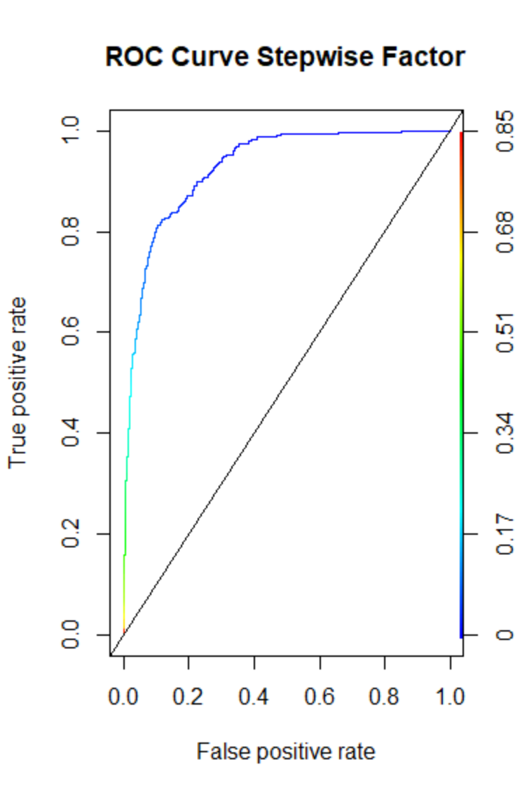

AUC Stepwise factor: 0.9273478

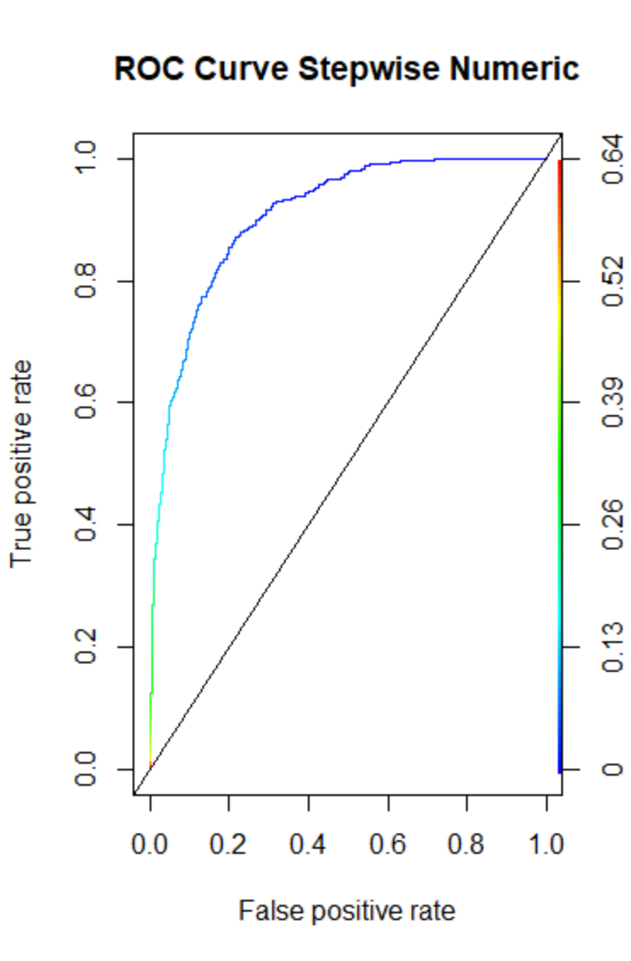

AUC Stepwise numeric 0.9066414

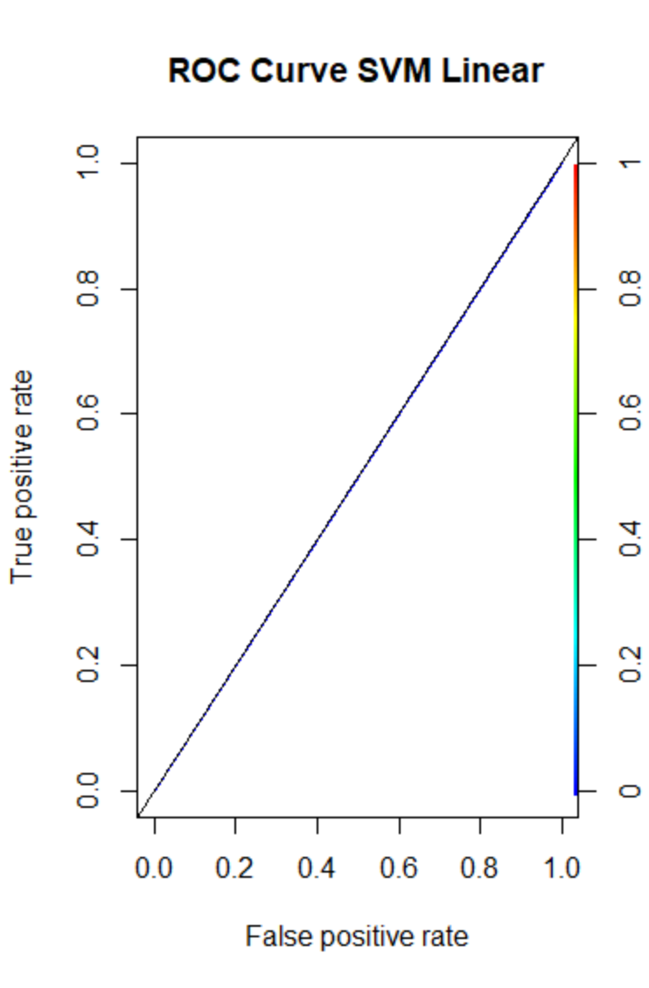

AUC for SVML 0.5